SUPPLEMENTARY NOTE

Five endometrial cancer risk loci identified through genome-wide association analysis

Timothy HT Cheng^{1,57}, Deborah J Thompson^{2,57}, Tracy A O’Mara³, Jodie N Painter³, Dylan M Glubb³, Susanne Flach¹, Annabelle Lewis¹, Juliet D French³, Luke Freeman-Mills¹, David Church¹, Maggie Gorman¹, Lynn Martin¹, National Study of Endometrial Cancer Genetics Group (NSECG)^{1, 4}, Shirley Hodgson⁵, Penelope M Webb³, The Australian National Endometrial Cancer Study Group (ANECS)^{3, 4}, John Attia^{6, 7}, Elizabeth G Holliday^{6, 7}, Mark McEvoy⁷, Rodney J Scott^{6, 8-10}, Anjali K Henders³, Nicholas G Martin³, Grant W Montgomery³, Dale R Nyholt^{3, 11}, Shahana Ahmed¹², Catherine S Healey¹², Mitul Shah¹², Joe Dennis², Peter A Fasching^{13, 14}, Matthias W Beckmann¹⁴, Alexander Hein¹⁴, Arif B Ekici¹⁵, Per Hall¹⁶, Kamila Czene¹⁶, Hatef Darabi¹⁶, Jingmei Li¹⁶, Thilo Dörk¹⁷, Matthias Dürst¹⁸, Peter Hillemanns¹⁹, Ingo Runnebaum¹⁸, Frederic Amant²⁰, Stefanie Schrauwen²⁰, Hui Zhao^{21, 22}, Diether Lambrechts^{21, 22}, Jeroen Depreeuw²⁰⁻²², Sean C Dowdy²³, Ellen L Goode²⁴, Brooke L Fridley²⁵, Stacey J Winham²⁴, Tormund S Njølstad^{26, 27}, Helga B Salvesen^{26, 27}, Jone Trovik^{26, 27}, Henrica MJ Werner^{26, 27}, Katie Ashton^{6, 9, 10}, Geoffrey Otton²⁸, Tony Proietto²⁸, Tao Liu²⁹, Miriam Mints³⁰, Emma Tham^{29, 31}, RENDOCAS^{4, 29}, CHIBCHA Consortium^{1, 4}, Mulin Jun Li³², Shun H Yip³², Junwen Wang³², Manjeet K Bolla², Kyriaki Michailidou², Qin Wang², Jonathan P Tyrer¹², Malcolm Dunlop^{33, 34}, Richard Houlston³⁵, Claire Palles¹, John L Hopper³⁶, AOCS Group^{3, 4, 37}, Julian Peto³⁸, Anthony J Swerdlow^{35, 39}, Barbara Burwinkel^{40, 41}, Hermann Brenner⁴²⁻⁴⁴, Alfons Meindl⁴⁵, Hiltrud Brauch^{44, 46, 47}, Annika Lindblom²⁹, Jenny Chang-Claude^{48, 49}, Fergus J Couch^{24, 50}, Graham G Giles^{36, 51, 52}, Vessela N Kristensen⁵³⁻⁵⁵, Angela Cox⁵⁶, Julie M Cunningham⁵⁰, Paul D P Pharoah¹², Alison M Dunning¹², Stacey L Edwards³, Douglas F Easton^{2, 12}, Ian Tomlinson¹, Amanda B Spurdle³

¹ Wellcome Trust Centre for Human Genetics, University of Oxford, Oxford, UK.
² Centre for Cancer Genetic Epidemiology, Department of Public Health and Primary Care, University of Cambridge, Cambridge, UK.
³ Department of Genetics and Computational Biology, QIMR Berghofer Medical Research Institute, Brisbane, QLD, Australia.
⁴ A list of members and affiliations appears in the Supplementary Note.
⁵ Department of Clinical Genetics, St George’s, University of London, London, UK.
⁶ Hunter Medical Research Institute, John Hunter Hospital, Newcastle, NSW, Australia.
⁷ Centre for Clinical Epidemiology and Biostatistics, School of Medicine and Public Health, University of Newcastle, NSW, Australia.
⁸ Hunter Area Pathology Service, John Hunter Hospital, Newcastle, NSW, Australia.
⁹ Centre for Information Based Medicine, University of Newcastle, NSW, Australia.
¹⁰ School of Biomedical Sciences and Pharmacy, University of Newcastle, Newcastle, NSW, Australia.
¹¹ Institute of Health and Biomedical Innovation, Queensland University of Technology, Brisbane, Australia.
¹² Centre for Cancer Genetic Epidemiology, Dept of Oncology, University of Cambridge, Cambridge, UK.
¹³ University of California at Los Angeles, Department of Medicine, Division of Hematology/Oncology, David Geffen School of Medicine, Los Angeles, CA, USA.
¹⁴ Department of Gynecology and Obstetrics, University Hospital Erlangen, Friedrich-Alexander University Erlangen-Nuremberg, Erlangen, Germany.
¹⁵ Institute of Human Genetics, University Hospital Erlangen, Friedrich-Alexander-University Erlangen-Nuremberg, Erlangen, Germany.
¹⁶ Department of Medical Epidemiology and Biostatistics, Karolinska Institutet, Stockholm, Sweden.
¹⁷ Hannover Medical School, Gynaecology Research Unit, Hannover, Germany.
¹⁸ Department of Gynaecology, Jena University Hospital - Friedrich Schiller University, Jena, Germany.
¹⁹ Hannover Medical School, Clinics of Gynaecology and Obstetrics, Hannover, Germany.
²⁰ Department of Obstetrics and Gynecology, Division of Gynecologic Oncology, University Hospitals, KU Leuven - University of Leuven, Belgium.
²¹ Vesalius Research Center, VIB, Leuven, Belgium.

Detailed Description of the Case and Control Sample Sets

A summary of the studies included in the GWAS and both additional genotyping phases is shown in Supplementary Table 1, with additional details provided below. Supplementary Figure 1 provides a flow diagram of the overall study design. All studies were of women of European ancestry. All studies have the relevant IRB approval in each country in accordance with the principles embodied in the Declaration of Helsinki, and informed consent was obtained from all participants. A total of 7,737 cases and 37,144 controls were included in this analysis. Cases and controls were matched based on geographical location and case-control clustering in principal components analysis (PCA) (Supplementary Figure 1).

Endometrial cancer case and control GWAS Sample Sets:

Quality control (QC) was applied to all GWAS sets, following standard QC approaches detailed in Spurdle et al¹. Also see online methods.

NSECG
National Study of the Genetics of Endometrial Cancer (NSECG) cases were identified from collaborating clinicians throughout the UK from 2008 to 2013, taking care not to recruit from centres involved in SEARCH. Inclusion criteria were adenocarcinomas of the uterus presenting at 70 years of age or younger. Almost all cases were incident and sampled within 6 months of diagnosis. Peripheral blood was collected from each participant and DNA extracted using standard methods and the participants completed the associated questionnaire. Tumour histology was confirmed from routine hospital reports and further details of histopathology and other tumor pathology characteristic was abstracted from these clinical pathology reports. 925 samples were genotyped using the Ilumina 660W Quads in the GWAS scan, 965 samples were genotyped in the phase 1 additional genotyping using iCOGS arrays, and a further 1195 were genotyped using KASPar and Fluidigm genotyping for the second phase. There was no overlap in samples used and all cases were of European ancestry.

ANECS
The Australian National Endometrial Cancer Study (ANECS) is an Australian population-based case-control family study of cancer of the uterine corpus². Women aged 18-79, newly diagnosed with histologically confirmed primary cancer of the endometrium between July 2005 and December 2007 were identified through major hospitals nationally, and also from state-based cancer registries. Excluding women who could not be contacted (mostly due to death, illness or failure to contact), case participation rate was 63%. Participants completed a detailed questionnaire providing clinical and epidemiological information, including ethnicity of all four grandparents. Information on tumor pathology characteristics was abstracted in standardized format from clinical pathology reports for all patients. 606 ANECS samples all of endometrioid-only histology were used for the original endometrial cancer case-control GWAS and a further 538 were genotyped using iCOGS for the first additional genotyping phase.

SEARCH
The Studies of Epidemiology and Risk factors in Cancer Heredity (SEARCH) is an ongoing population-based study with cases ascertained through the Eastern Cancer Registration and Information Centre (http://www.ecric.org.uk). All women diagnosed with endometrial cancer between the ages of 18-69 years (average age of diagnosis 58 years) from August 2001 to September 2007 were eligible for inclusion. Approximately 54% of eligible patients have enrolled in the study. Women taking part in the study were asked to provide a 20ml blood sample for DNA analysis, and to complete a comprehensive epidemiological questionnaire. Controls were also drawn from SEARCH (http://ccge.medschl.cam.ac.uk/search/), but had no prior history of cancer at the time of recruitment. They were female, also between the ages of 18-69 at the time of recruitment and matched to cases in geographical profile. Approximately 35% of eligible controls enrolled in the study. All participants reported Caucasian ethnicity. Information on tumor pathology characteristics was provided by the Eastern Cancer Registration and Information Centre and was derived from clinical pathology reports for all patients. 681 SEARCH samples with endometroid-only histology were used in the original GWAS and a further 773 non-overlapping cases were used in the iCOGS analysis.

UK1/CORGI
The UK1 Colorectal Tumour Gene Identification (CoRGI) is a GWAS for colorectal neoplasia³. The 894 controls matched with the NSECG cases were spouses or partners unaffected by cancer and without a personal family history (to second degree relative level) of colorectal neoplasia. Known dominant polyposis syndromes, HNPCC/Lynch syndrome or bi-allelic MUTYH mutation carriers were excluded. All cases and controls were of white UK ethnic origin. Genotyping was done on the Illumina Hap550 arrays.

Scotland Phase 1
Scotland Phase1 is a colorectal cancer GWAS⁴ with 1012 cancer-free population controls Known dominant polyposis syndromes, HNPCC/Lynch syndrome or bi-allelic MUTYH mutation carriers were excluded. Control subjects were sampled from the Scottish population NHS registers, matched by age (±5 years), gender and area of residence within Scotland. A subset of 392 controls from this dataset were matched with the NSECG GWAS cases and these were chosen based on case-control clustering on PCA. Genotyping was done on the Illumina Hap300 and Hap 240S arrays.

QIMR
The Queensland Institute of Medical Research (QIMR) control sample is a subsection of subjects recruited as part of the Brisbane Adolescent Twin Study^{5,6}. Twins were recruited from schools in Brisbane, Australia and surrounding areas of southeast Queensland and were examined close to their 12th birthday. Blood was obtained from all twins and most parents. Parents were asked the ancestry of all eight great-grandparents of the twins. More than 95% of great-grandparents were identified as being of northern European ancestry, mainly from Britain and Ireland. This analysis used genotype data from parents and siblings only, extracted from an existing Illumina 610K BeadChip genome-wide association scan⁷ and recalled using the Illuminus algorithm. After QC, 1846 QIMR controls were available for inclusion in the analysis.

HCS
The Hunter Community Study (HCS) is a population-based cohort study consisting of men and women aged 55-85 years of age in Newcastle, New South Wales, Australia⁸. Participants were randomly selected from the NSW State electoral roll (listing on the electoral roll is compulsory in Australia) and contacted between December 2004 and December 2007. Non-English speaking persons and those living in a residential aged-care facility were ineligible for participation in the study. Participants were asked to complete five self-report questionnaires as well as attend the HCS data collection centre so clinical measures could be obtained. In total, 44.5% of eligible controls agreed to participate in this study. Genotype data for this study were extracted from an existing Illumina 610K BeadChip genome-wide association study scan and recalled using the Illuminus algorithm. After QC, 1237 HCS controls were available for inclusion in the analysis.

WTCCC
Controls utilized were genotyped as part of the Wellcome Trust Case Control Consortium (WTCCC2)⁹. These controls are drawn from two sources: 2,674 controls from the 1958 Birth Cohort (1958BC), a population-based study in the United Kingdom of individuals born in 1 week in 1958¹⁰; and 2,501 controls identified through the UK National Blood Service (NBS)⁹. 1958BC controls were matched with NSECG cases and the NBS controls were matched with SEARCH cases.

Phase 1 additional genotyping - iCOGS Case Sample Sets:

All samples in this phase were genotyped as part of the Collaborative Oncological Gene-environment Study (iCOGS) initiative on a custom Ilumina Infinium iSelect array. Cases from ANECS and SEARCH and NSECG were recruited as detailed above, and are non-overlapping.

BECS
The Bavarian Endometrial Cancer Cases and Controls Study (BECS) is a single-center case-control study, conducted between 2002 and 2008, with the aim of investigating genetic and epidemiological risk factors for endometrial cancer. Cases were either incident cases referred to the University Hospital Erlangen by surrounding practitioners (66% of the case sample set), or prevalent cases that were outpatients in follow-up care approached within 6.2 (±4.6 SD) years after treatment for primary endometrial cancer in the same hospital (34% of the case sample set). Epidemiological information was collected by a structured questionnaire completed during an interview and clinical data for the cases was obtained from clinical health records.

CAHRES
Details of the population selection process have been published previously for the Cancer Hormone Replacement Epidemiology Study (CAHRES)¹¹. Formerly known as the Singapore and Sweden Breast/Endometrial Cancer Study (SASBAC), this population based case-control study was conducted among Swedish women aged 50-74 years, who were residing in Sweden between January 1st 1994 and December 31st 1995. Endometrial cancer cases were identified through the nation-wide cancer registries in Sweden. All participants provided detailed questionnaire information. For endometrial cancer, histological specimens were reviewed and re-classified by the study pathologist. All participants reported Caucasian ethnicity.

HJECS
The Hannover-Jena Endometrial Cancer Study (HJECS), a hospital-based case-control study, included 250 German women, aged 31-89 years, who were recruited either at the Friedrich Schiller University of Jena or at Hannover Medical School after having been diagnosed with histologically confirmed primary incident endometrial carcinoma between 2004 and 2010. Epidemiological data were obtained from questionnaires, and information on tumor stage and histology was obtained from pathology and clinical reports. Over 98% were of German descent. Interviews were conducted at either the Friedrich Schiller University of Jena or at Hannover Medical School, and peripheral blood was collected for the extraction of DNA from white blood cells.

LES
The Leuven Endometrial Study (LES) is a hospital based case-control study. Eligible cases, identified by active surveillance of electronic patient files at the Leuven University Hospital, were white women aged 27-80 years diagnosed with endometrial cancer. Clinical data for endometrial cancer patients were recorded during interview at the time of diagnosis, and from pathology reports. All medical records were reviewed by trained abstractors and pathology reports compatible with primary, invasive, epithelial endometrial adenocarcinoma of all stages (I –IV) and all grades were consulted. Participation rates exceeded 95% for cases.

MECS
The Mayo Endometrial Cancer Study (MECS) includes a clinic-based prospective collection of primary endometrial cases diagnosed from 2008 to 2011 and seen at Mayo Clinic Rochester with primary endometrial cancer diagnosed at age 18 and older. DNA was isolated from white blood cells using a Qiagen isolation kit. DNA concentration was measured with picogreen. Clinical data were abstracted from electronic medical records and supplemented with a risk factor questionaire. Control data were obtained from Mayo Clinic OCAC controls (MAY) and BCAC controls (MCBCS).

MoMaTEC
Molecular Markers in Treatment of Endometrial Cancer (MoMaTEC) cases were recruited from an unselected patient population primarily treated for endometrial carcinoma at Haukeland University Hospital, Bergen during 2001-2009. This is the referral hospital for Hordaland county; the area is demographically well defined, with about 450,000 inhabitants, representing approximately 10% of the Norwegian population and with a similar incidence rate and prognosis as the total Norwegian population of endometrial cancers^{12–14}. Clinical Information for cases regarding age, FIGO stage, histologic subtype, grade and prognosis was extracted from medical records. DNA was extracted from peripheral blood samples.

NECS
The Newcastle Endometrial Cancer Study (NECS) includes histologically confirmed endometrial cancer cases consecutively recruited from 1992 up to 2005 at the Hunter Centre for Gynaecological Cancer, John Hunter Hospital, Newcastle, New South Wales, Australia¹⁵. The final analysis included 194 endometrial cancer patients. Data on reproductive and environmental risk factors including ethnicity was collected using self reported questionnaires. Information regarding recurrence, stage, grade and histology of endometrial cancer was collected from medical records. Patients presenting at this hospital-based site were captured by ANECS recruitment from 2005 onwards.

RENDOCAS
The Registry of Endometrial Cancer in Sweden (RENDOCAS) is a hospital based case-control study. Patients (n=520) who underwent surgery for endometrial cancer at Karolinska University hospital Solna, Sweden between 2008 and 2011 were included in the study. For each patient, the following was collected: blood and tumor samples; detailed family history and formulation of a pedigree where all suspected cancer cases were verified in medical records/pathology report if possible; questionnaire covering relevant environmental factors underlying endometrial cancer.

Phase 1 additional genotyping - iCOGS Control Sample Sets:

As indicated in Supplementary Table 1, iCOGS endometrial cancer case sample sets were matched with controls from the same countries and also clustered with cases in PCA (Supplementary Figure 2). Controls were genotyped using the same iCOGS array and data were largely drawn from healthy controls participating in the Breast Cancer Association Consortium (BCAC)¹⁶ part of the iCOGS initiative. Additional controls were from the Mayo Clinic via the Ovarian Cancer Association Consortium (OCAC)¹⁷, and Norwegian female controls recruited in Bergen for use in the MoMaTEC case-control genotyping studies.

Endometrioid and non-endometrioid histology analysis

Cases were defined as having endometrioid subtype based on pathology report of endometrioid histology only. Non-endometrioid subtypes included carcinosarcoma, clear cell, serous, mucinous, and tumours of mixed histology (any combination). 6,635 (86%) of the 7,737 endometrial cancer cases displayed endometrioid-only histology and association testing and meta-analysis was also conducted using endometrioid-only histology cases. The results of this analysis for the novel risk loci are shown in Table 1. Endometrioid-only phase 1 meta-analysis (n=5,590) found only novel risk loci that were identified in the all histologies analysis (Table 1, Supplementary Table 2). Analysis of endometrial cancer cases that displayed non-endometrioid histology (in Phase 1, or the final meta-analysis) found no SNPs near genome-wide significance, as expected given the limited statistical power.

Ishikawa and ECC-1 cells

Results from Ishikawa and ECC-1 cells are listed separately in publicly available ENCODE¹⁸ tier 3 data but STR-profiling has shown that these two cell lines are very similar¹⁹. Based on the results presented by Korch et al., the International Cell Line Authentication Committee (ICLAC) recommended in the 2013 Database of Cross-Contaminated or Misidentified Cell Lines that ECC-1 be re-identified as Ishikawa cells. Our in vitro functional analysis for the 13q22 locus made use of our supply of Ishikawa cells for FAIRE and ChIP experiments and ECC-1 cells for luciferase reporter assays. Both cell lines displayed identical genotypes for rs9600103 and rs11841589, similar KLF5 expression levels, and 20x sequencing using the Ion AmpliSeq™ Comprehensive Cancer Panel confirmed that variants in Ishikawa and ECC-1 are 90% concordant (based on 3,004 exonic SNVs in 409 cancer-related genes). In line with these findings and ICLAC recommendations, we have presented functional work on these cells as Ishikawa cells.

ECAC Study Collaborators

The ANECS Group comprises: AB Spurdle, PM Webb, J Young (QIMR Berghofer Medical Research Institute); Consumer representative: L McQuire; Clinical Collaborators: NSW: S Baron-Hay, D Bell, A Bonaventura, A Brand, S Braye, J Carter, F Chan, C Dalrymple, A Ferrier (deceased), G Gard, N Hacker, R Hogg, R Houghton, D Marsden, K McIlroy, G Otton, S Pather, A Proietto, G Robertson, J Scurry, R Sharma, G Wain, F Wong; Qld: J Armes, A Crandon, M Cummings, R Land, J Nicklin, L Perrin, A Obermair, B Ward; SA: M Davy, T Dodd, J Miller, M Oehler, S Paramasivum, J Pierides, F Whitehead; Tas: P Blomfield, D Challis; Vic: D Neesham, J Pyman, M Quinn, R Rome, M Weitzer; WA: B Brennan, I Hammond, Y Leung, A McCartney (deceased), C Stewart, J Thompson; Project Managers: S O'Brien, S Moore; Laboratory Manager: K Ferguson; Pathology Support: M Walsh; Admin Support: R Cicero, L Green, J Griffith, L Jackman, B Ranieri; Laboratory Assistants: M O'Brien, P Schultz; Research Nurses: B Alexander, C Baxter, H Croy, A Fitzgerald, E Herron, C Hill, M Jones, J Maidens, A Marshall, K Martin, J Mayhew, E Minehan, D Roffe, H Shirley, H Steane, A Stenlake, A Ward, S Webb, J White.

CHIBCHA (study of hereditary cancer in Europe and Latin America) collaborators include: Ma. Magdalena Echeverry de Polanco, Mabel Elena Bohórquez, Rodrigo Prieto, Angel Criollo, Carolina Ramírez, Ana Patricia Estrada, Jhon Jairo Suárez (Grupo de Citogenética Filogenia y Evolución de Poblaciones, Universidad del Tolima, Colombia); Augusto Rojas Martinez (Center for Research and Development in Health Sciences, Universidad Autónoma de Nuevo León, Monterrey, Mexico); Silvia Rogatto, Samuel Aguiar Jnr, Ericka Maria Monteiro Santos (Department of Urology, School of Medicine, UNESP - São Paulo State University, Botucatu, Brazil); Monica Sans, Valentina Colistro, Pedro C. Hidalgo, Patricia Mut (Department of Biological Anthropology, College of Humanities and Educational Sciences, University of the Republic, Magallanes, Montevideo, Uruguay); Angel Carracedo, Clara Ruiz Ponte, Ines Quntela Garcia (Fundacion Publica Galega de Medicina Xenomica, CIBERER, Genomic Medicine Group-University of Santiago de Compostela, Hospital Clinico, Santiago de Compostela, Galicia, Spain); Sergi Castellvi-Bel (Department of Gastroenterology, Institut de Malalties Digestives i Metabòliques, Hospital Clínic, Centro de Investigación Biomédica en Red de Enfermedades Hepáticas y Digestivas, IDIBAPS, University of Barcelona, Barcelona, Catalonia, Spain); Manuel Teixeira (Department of Genetics, Portuguese Oncology Institute, Rua Dr, António Bernardino de Almeida, Porto, Portugal).

The NSECG Group comprises: Ian Tomlinson (Oxford University); M Adams, A Al-Samarraie, S Anwar, R Athavale, S Awad, A Bali, A Barnes, G Cawdell, S Chan, K Chin, P Cornes, M Crawford, J Cullimore, S Ghaem-Maghami, R Gornall, J Green, M Hall, M Harvey, J Hawe, A Head, J Herod, M Hingorani, M Hocking, C Holland, T Hollingsworth,J Hollingworth, T Ind, R Irvine, C Irwin, M Katesmark, S Kehoe, G Kheng-Chew, K Lankester, A Linder, D Luesley, C B-Lynch,V McFarlane, R Naik, N Nicholas, D Nugent, S Oates, A Oladipo, A Papadopoulos, S Pearson, D Radstone, S Raju, A Rathmell, C Redman, M Rymer, P Sarhanis, G Sparrow, N Stuart, S Sundar, A Thompson, S Tinkler, S Trent, A Tristram, N Walji, R Woolas.

RENDOCAS investigators include: Annika Lindblom, Gerasimos Tzortzatos, Miriam Mints, Emma Tham, Ofra Castro, Kristina Gemzell-Danielsson.

SEARCH collaborators include: Helen Baker, Caroline Baynes, Don Conroy, Bridget Curzon, Patricia Harrington, Sue Irvine, Craig Luccarini, Rebecca Mayes, Hannah Munday, Barbara Perkins, Daisy Pharoah, Radka Platte, Anne Stafford and Judy West.

BCAC and OCAC Study Collaborators (for control samples):

The Australian Ovarian Cancer Study Group comprises: R Stuart-Harris; NSW‐ F Kirsten, J Rutovitz, P Clingan, A Glasgow, A Proietto, S Braye, G Otton, J Shannon, T Bonaventura, J Stewart, S Begbie, M Friedlander, D Bell, S Baron-Hay, A Ferrier (deceased), G Gard, D Nevell, N Pavlakis, S Valmadre, B Young, C Camaris, R Crouch, L Edwards, N Hacker, D Marsden, G Robertson, P Beale, J Beith, J Carter, C Dalrymple, R Houghton, P Russell, L Anderson, M Links, J Grygiel, J Hill, A Brand, K Byth, R Jaworski, P Harnett, R Sharma, G Wain; QLD- D Purdie, D Whiteman, B Ward, D Papadimos, A Crandon, M Cummings, K Horwood. A Obermair, L Perrin, D Wyld, J Nicklin; SA- M Davy, MK Oehler, C Hall, T Dodd, T Healy, K Pittman, D Henderson, J Miller, J Pierdes, A Achan; TAS- P Blomfield, D Challis, R McIntosh, A Parker; VIC- B Brown, R Rome, D Allen, P Grant, S Hyde, R Laurie M Robbie, D Healy, T Jobling, T Manolitsas, J McNealage, P Rogers, B Susil, E Sumithran, I Simpson, I Haviv, K Phillips, D Rischin, S Fox, D Johnson, S Lade, P Waring, M Loughrey, N O’Callaghan, B Murray, L Mileshkin, P Allan; V Billson, J Pyman, D Neesham, M Quinn, A Hamilton, C Underhill, R Bell, LF Ng, R Blum, V Ganju; WA- I Hammond, A McCartney (deceased), C Stewart, Y Leung, M Buck, N Zeps (WARTN); AOCS Management Group- DDL Bowtell, AC Green, G Chenevix-Trench, A deFazio, D Gertig, PM Webb.

BSUCH collaborator: Peter Bugert

ESTHER collaborators: Volker Arndt, Heiko Müller, Christa Stegmaier

GENICA Network collaborators: Wing-Yee Lo, Christina Justenhoven, Ute Hamann, Thomas Brüning, Beate Pesch, Yon-Dschun Ko, Sylvia Rabstein, Anne Lotz, Christina Baisch, Hans-Peter Fischer, Volker Harth.

Supplementary Acknowledgements

The authors thank the many individuals who participated in this study and the numerous institutions and their staff who have supported recruitment.

ANECS thanks members of the Molecular Cancer Epidemiology and Cancer Genetic laboratories at QIMR Berghofer Medical Research Institute for technical assistance, and the ANECS research team for assistance with the collection of risk factor information and blood samples. ANECS also gratefully acknowledges the cooperation of the following institutions: NSW: John Hunter Hospital, Liverpool Hospital, Mater Misericordiae Hospital (Sydney), Mater Misericordiae Hospital (Newcastle), Newcastle Private Hospital, North Shore Private Hospital, Royal Hospital for Women, Royal Prince Alfred Hospital, Royal North Shore Hospital, Royal Prince Alfred Hospital, St George Hospital; Westmead Hospital, Westmead Private Hospital; Qld: Brisbane Private Hospital, Greenslopes Hospital, Mater Misericordiae Hospitals, Royal Brisbane and Women's Hospital, Wesley Hospital, Queensland Cancer Registry; SA: Adelaide Pathology Partners, Burnside Hospital, Calvary Hospital, Flinders Medical Centre, Queen Elizabeth Hospital, Royal Adelaide Hospital, South Australian Cancer Registry; Tas: Launceston Hospital, North West Regional Hospitals, Royal Hobart Hospital; Vic: Freemasons Hospital, Melbourne Pathology Services, Mercy Hospital for Women, Royal Women's Hospital, Victorian Cancer Registry; WA: King Edward Memorial Hospital, St John of God Hospitals Subiaco & Murdoch, Western Australian Cancer Registry.
SEARCH thanks the SEARCH research team for recruitment, and also acknowledges the assistance of the Eastern Cancer Registration and Information Centre for subject recruitment.
BECS thanks Reiner Strick, Silke Landrith and Sonja Oeser for their logistic support during the study.
CAHRES (formerly known as SASBAC) thanks Li Yuqing from the Genome Institute of Singapore for contributions to this study, and also acknowledges previous input to SASBAC resource creation by Anna Christensson, Boel Bissmarck, Kirsimari Aaltonen, Karl von Smitten, Nina Puolakka, Christer Halldén, Lim Siew Lan and Irene Chen, Lena U. Rosenberg, Mattias Hammarström, and Eija Flygare.
HJECS thanks Wen Zheng, Hermann Hertel, and Tjoung-Won Park-Simon at Hannover Medical School for their contribution to sample recruitment.
LES gratefully acknowledges Helena Soenen, Gilian Peuteman and Dominiek Smeets for their technical assistance.
MECS thanks Tom Sellers, Catherine Phelan, Andrew Berchuck, and Kimberly Kalli, Amanda von Bismarck, Luisa Freyer and Lisa Rogmann.
MoMaTEC thanks Britt Edvardsen, Ingjerd Bergo and Mari Kyllsø Halle for technical assistance and Inger Marie Aksnes and Tor Audun Hervig at the Blood bank, Haukeland University Hospital for assistance with control recruitment.
NECS thanks staff at the University of Newcastle and the Hunter Medical Research Institute.
NSECG thank Ella Barclay and Lynn Martin for their contribution, and acknowledge the invaluable help of the National Cancer Research Network with the collection of study participants.
QIMR Berghofer thanks Margie Wright, Lisa Bowdler, Sara Smith, Megan Campbell and Scott Gordon for control sample collection and data processing, Kerenaftali Klein for statistical advice and Brendan Ryan for assistance with the figures.
RENDOCAS thanks Berith Wejderot, Sigrid Sahlen, Tao Liu, Margareta Ström, Maria Karlsson, and Birgitta Byström for their contribution to the study.
BSUCH thanks the Medical Faculty, Mannheim, the Diemtmar Hopp Foundation and the German Cancer Research Center.
MCCS was made possible by the contribution of many people, including the original investigators and the diligent team who recruited the participants and who continue working on follow up. We would like to express our gratitude to the many thousands of Melbourne residents who continue to participate in the study.
The UKBGS thank Breakthrough Breast Cancer and the Institute of Cancer Research for support and funding, and the Study participants, Study staff, and the doctors, nurses and other health care staff and data providers who have contributed to the Study. The ICR acknowledges NHS funding to the NIHR Biomedical Research Centre.
In addition, the iCOGS study would not have been possible without the contributions of: Andrew Berchuck (OCAC), Rosalind A. Eeles, Ali Amin Al Olama, Zsofia Kote-Jarai , Sara Benlloch (PRACTICAL), Georgia Chenevix-Trench, Antonis Antoniou, Lesley McGuffog, Fergus Couch and Ken Offit (CIMBA), Andrew Lee, and Ed Dicks, Craig Luccarini and the staff of the Centre for Cancer Genetic Epidemiology Laboratory (Cambridge), Javier Benitez, Anna Gonzalez-Neira and the staff of the CNIO genotyping unit, Jacques Simard and Daniel C. Tessier, Francois Bacot, Daniel Vincent, Sylvie LaBoissière and Frederic Robidoux and the staff of the McGill University and Génome Québec Innovation Centre, Stig E. Bojesen, Sune F. Nielsen, Borge G. Nordestgaard, and the staff of the Copenhagen DNA laboratory, Sharon A. Windebank, Christopher A. Hilker, Jeffrey Meyer and the staff of Mayo Clinic Genotyping Core Facility.

Acknowledgments of Funding to BCAC/OCAC control groups

The ESTHER study was funded by the Baden-Württemberg state Ministry of Science, Research and Arts (Stuttgart, Germany), the Federal Ministry of Education and Research (Berlin, Germany) and the Federal Ministry of Family Affairs, Senior Citizens, Women and Youth (Berlin, Germany).
The GENICA was funded by the Federal Ministry of Education and Research (BMBF) Germany grants 01KW9975/5, 01KW9976/8, 01KW9977/0 and 01KW0114, the Robert Bosch Foundation, Stuttgart, Deutsches Krebsforschungszentrum (DKFZ), Heidelberg, Institute for Prevention and Occupational Medicine of the German Social Accident Insurance, Institute of the Ruhr University Bochum (IPA), Germany, as well as the Department of Internal Medicine, Evangelische Kliniken Bonn gGmbH, Johanniter Krankenhaus, Bonn, Germany.
Financial support for the KARBAC study was provided through the regional agreement on medical training and clinical research (ALF) between Stockholm County Council and Karolinska Institutet, as well as the Swedish Cancer Society.
The MARIE study was supported by the Deutsche Krebshilfe e.V. [70-2892-BR I], the Hamburg Cancer Society and the German Cancer Research Center
MAY was supported by R01-CA122443, P50-CA136393, the Fred C. and Katherine B. Andersen Foundation, and the Mayo Foundation.
MCBCS recognizes funding from the Breast Cancer Research Foundation (BCRF), the David F. and Margaret T. Grohne Family Foundation, and the Ting Tsung and Wei Fong Chao Foundation
MCCS recruitment was funded by VicHealth and Cancer Council Victoria, and its follow-up has been continuously supported by infrastructure provided by Cancer Council Victoria.
UKBGS was funded by Breakthrough Breast Cancer and the Institute of Cancer Research, which acknowledges NHS funding to the NIHR Biomedical Research Centre

Supplementary Figure 1: Endometrial cancer meta-analysis flow diagram.
This schematic figure illustrates the endometrial cancer case-control meta-analysis study design. The new NSECG GWAS was meta-analysed with a re-analysis of the original endometrial cancer GWAS (ANECS and SEARCH) and the iCOGS phase 1 genotypes (eight groups). This meta-analysis of 6,542 cases and 36,393 controls yielded 14 regions with SNPs P<10⁻⁵, of which five regions had SNPs P<10⁻⁷. These five SNPs were brought forward to the additional genotyping in a second phase, involving non-overlapping NSECG cases and controls, and were confirmed as novel genome-wide significant risk loci (P<5×10⁻⁸) in the overall meta-analysis of 7,737 cases and 37,144 controls.

Supplementary Figure 2: Quantile-quantile plots of the ranked trend test statistics for three GWAS and eight iCOGS groups.
The –log₁₀ transformed observed P-values (y-axis) were plotted against the expected P-values under the null hypothesis (x-axis). The red line denotes the expectation under no deviation from the null hypothesis. The QQ-plots show little evidence of genomic inflation and the λ_{GC} for each study are: NSECG GWAS 1.020, ANECS GWAS 1.021, SEARCH GWAS 1.002, ANECS iCOGS 1.036, SEARCH iCOGS 1.016, NESCG iCOGS 1.038, MECS iCOGS 1.007, LES iCOGS 1.034, BECS iCOGS 1.030, MoMaTEC iCOGS 1.034, CAHRES RENDOCAS iCOGS 1.037. For the three GWAS, all genotyped SNPs passing QC are displayed. For iCOGS, 105,000 SNPs after LD-pruning (r²<0.2) and >500kb from the 1,483 endometrial cancer prioritized SNPs on the iCOGS are displayed.

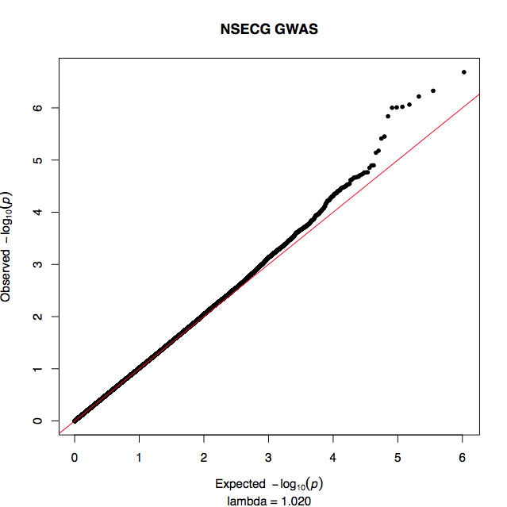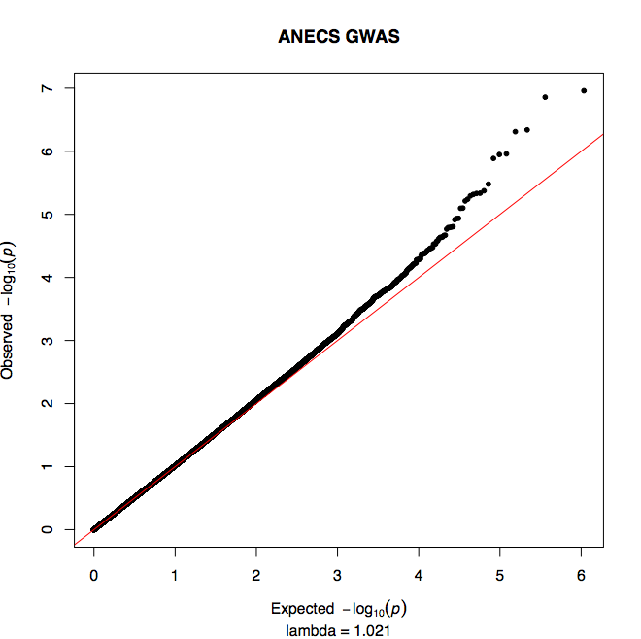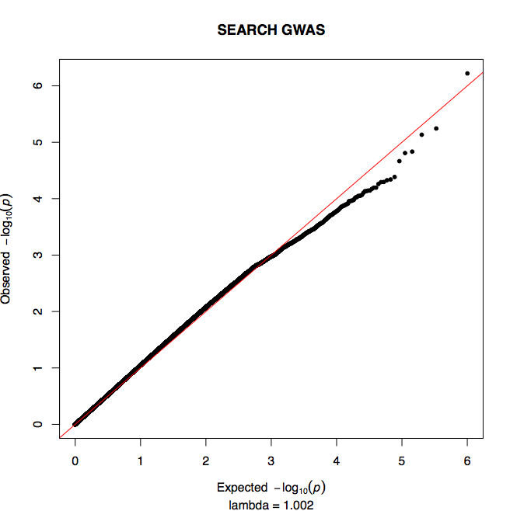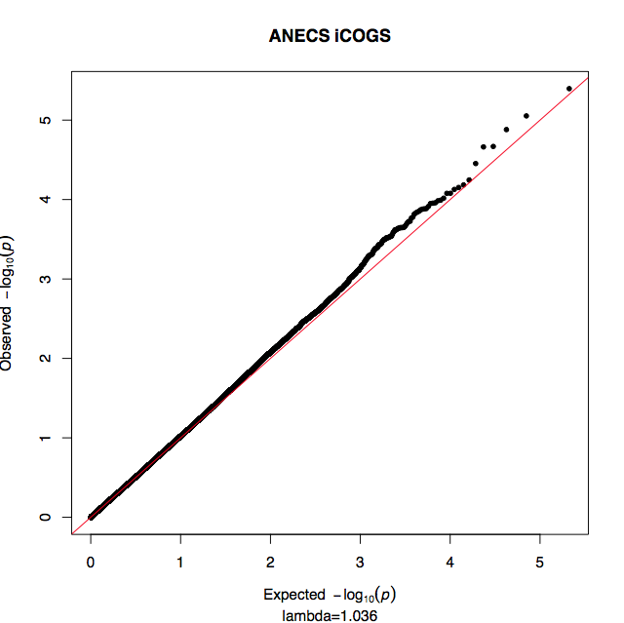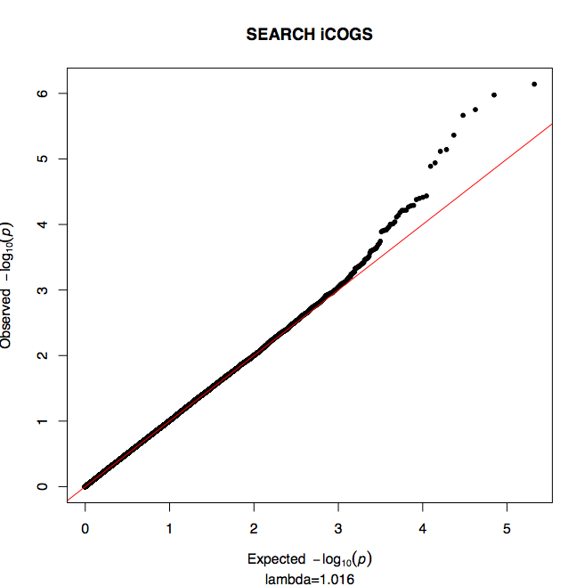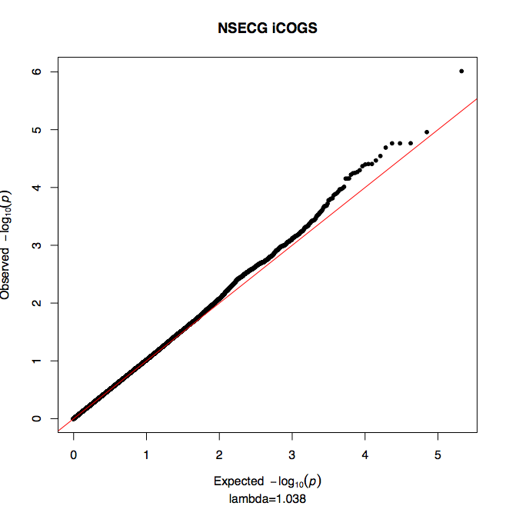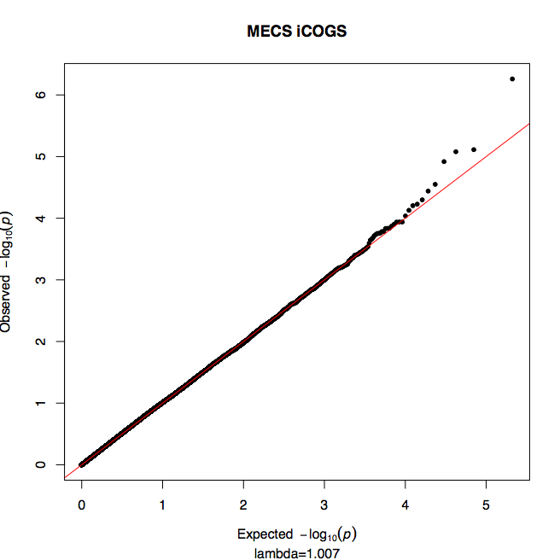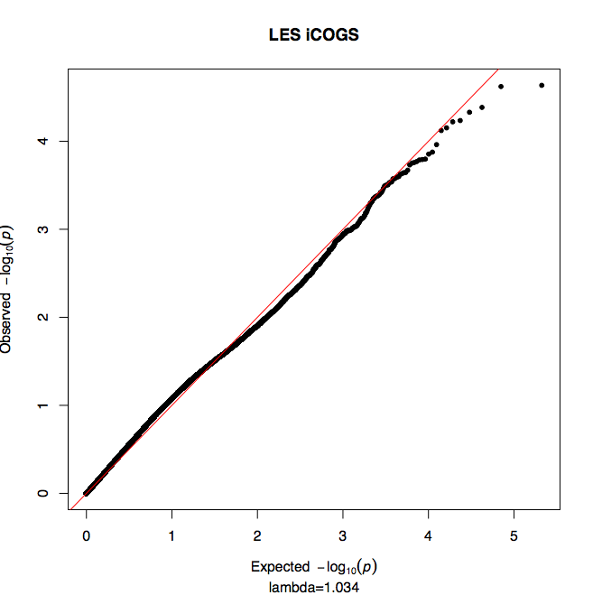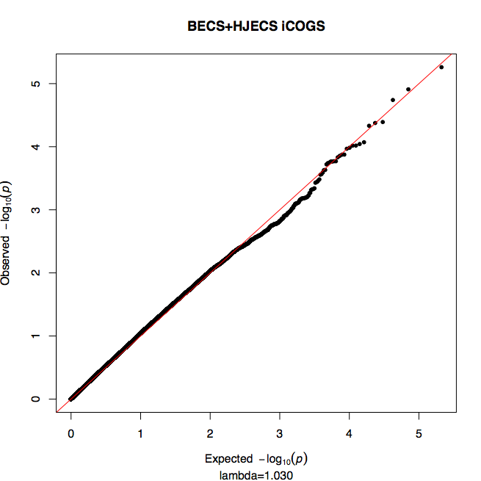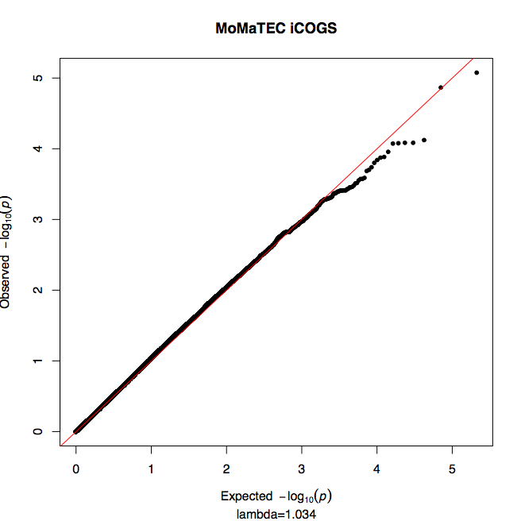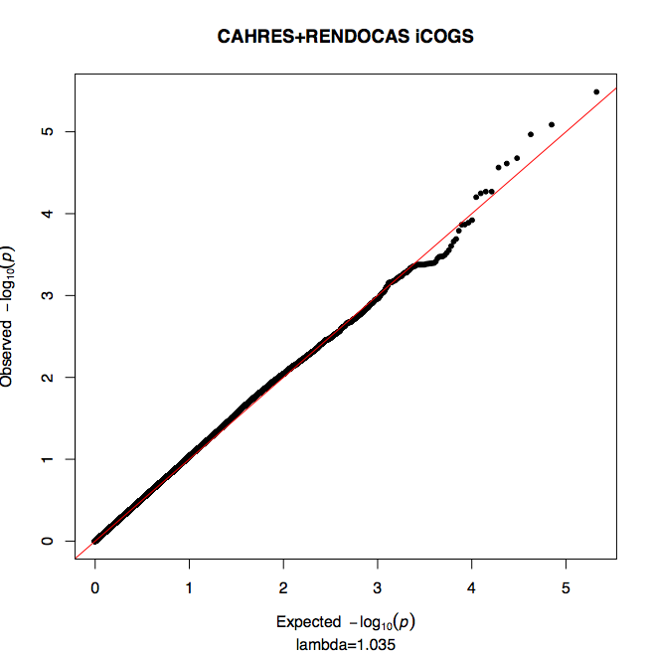

Supplementary Figure 3: Genetic landscape of novel endometrial cancer associated regions.
Plots for novel risk loci at a) 13q22.1, b) 6q22.31, c) 8q24.21, d) 15q15 and e) 14q32. SNPs in strong LD (r² > 0.7) with the lead endometrial cancer risk SNP have been plotted for each region and the lead SNP denoted in green. The second, independently associated SNP found at 8q24.21 after conditioning on the lead SNP is denoted in red (c). Previously reported cancer risk SNPs identified by GWAS at 8q24 are shown in blue (c), none of which are in LD (r2≤0.02) with endometrial cancer risk SNPs. Likely enhancers identified by Hnisz et al.²⁰ and PresTIGE²¹ that overlap endometrial cancer risk associated SNPs are depicted as colored bars, where the color of the likely enhancer matches the schematic of its predicted target gene, as determined by correlations with gene expression. As described in Online Methods Hnisz et al. predicted enhancer-gene interactions by identifying 'super-enhancers' (regions containing neighboring H3K27Ac modifications) from 86 cell and tissue types and then the expressed transcript with transcription start site closest to the centre of the super-enhancer was assigned as the target gene. PresTIGE pairs cell-type specific H3K4Me1 and gene expression data from 13 cell types to identify likely enhancer-gene interactions. Additional tracks include: Histone modifications associated with promoters (H3K4Me3) and enhancers (H3K4Me1 and H3K27Ac) from seven ENCODE Project cell types; DNaseI hypersensitivity sites (DHS) and transcription factor (TF) binding identified in 125 and 91 ENCODE Project cell types, respectively; DHS identified in Ishikawa endometrial cancer cells using DMSO vehicle and under estrogen (E2) stimulation are shown; transcription factor binding regions in Ishikawa cells that encompass endometrial cancer risk SNP loci are also displayed. For all risk loci, endometrial cancer risk associated SNPs co-locate with at least one enhancer predicted by cell-type specific analysis, implicating the following genes/transcripts as worthy of investigation: a) KLF5; b) HEY2, NCOA7; c) MYC, MIR1204, MIR1205, MIR1207, MIR1208; d) BMF, GPR176, SRP14, LOC100131089; e) AKT, ADSSL1, INF2, ZBTB42, SIVA1. For four loci (a, c, d and e), likely enhancers overlap with at least one region displaying evidence of regulatory activity (DHS and/or TF binding) in the single endometrial cancer cell line (Ishikawa) assayed by ENCODE.

a)

b)

c)

d)

e)

Supplementary Figure 4: Hi-C chromatin capture of 13q22 locus in Hela S3 cells. a) 5Kb KR normalized contact matrix in Hi-C experiment for HeLa S3 cells was used to represent the interaction pattern between KLF5 and risk locus rs11841589/rs9600103²². A loop was anchored at the KLF5 promoter and the risk locus (see b) for the small topologically associated domain and the red arrow for loop anchor), which indicated distal cis-regulatory element within the risk locus. The interaction between the rs11841589/rs9600103 risk locus with the KLF5 promoter was the strongest interaction observed out of the 262 protein-coding genes on chromosome 13 (P=0.004). The color scheme in the contact matrix is KR normalized score, with the black indicating a strong interaction.

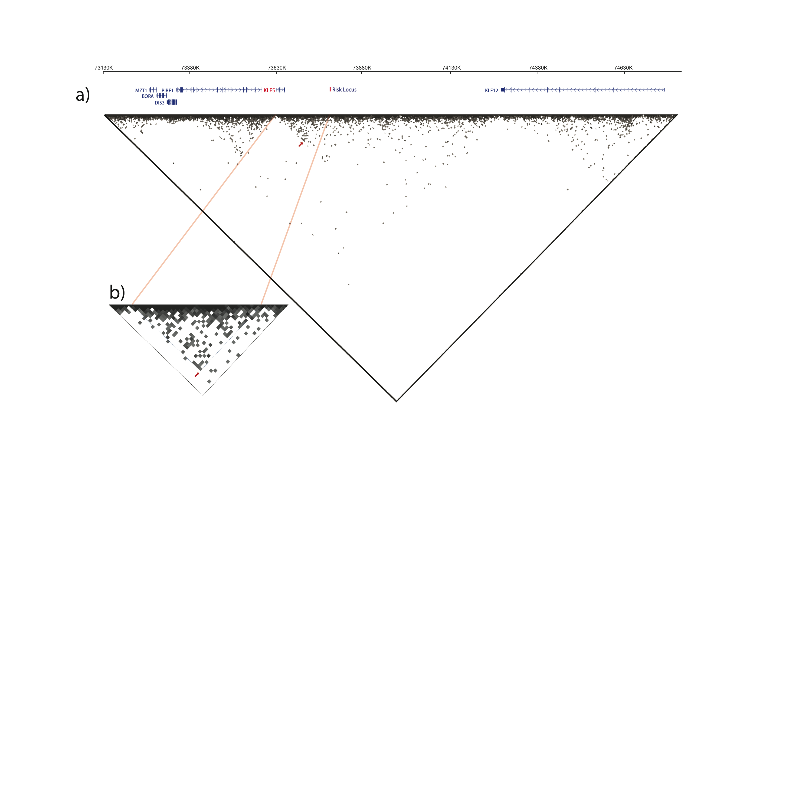

Supplementary Figure 5: Quantification of KLF5 expression in endometrial cancer cell lines. Expression of KLF5 in 11 endometrial cancer cell lines as described in Online methods using qRT-PCR, expression levels on the x-axis are relative to KLF5 expression in Ishikawa cells using the ddCT method.

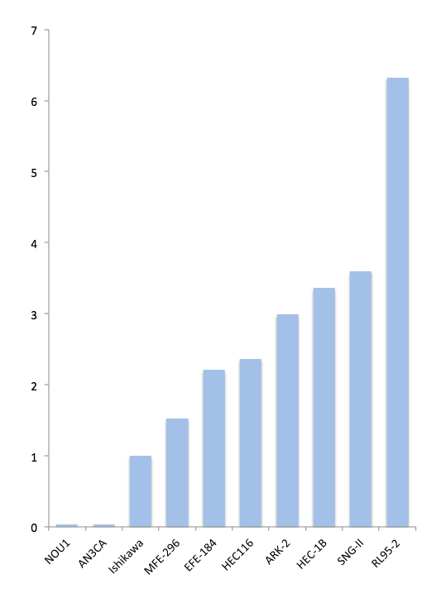

Supplementary Figure 6: Regional association plots for the five novel loci associated with endometrial cancer.
The -log₁₀ P values from the meta-analysis and regional imputation for NSECG, ANECS, SEARCH, and eight iCOGS groups are shown for SNPs at: a) 13q22.1, b) 6q22, c) & d) 8q24, e) 15q15 and f) 14q32.33. The SNP with the lowest P value at each locus is labelled and marked as a purple diamond, and the dot color represents the LD with the top SNP. The blue line shows recombination rates in cM/Mb. Compared with Figure 2, more SNPs are displayed in these plots. SNPs with info scores of more than 0.6 in iCOGS and more than 0.9 in NSECG, ANECS, and SEARCH are included.

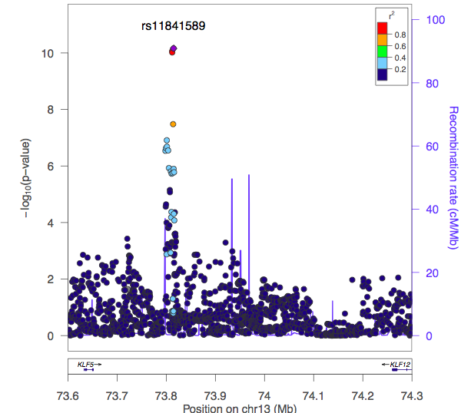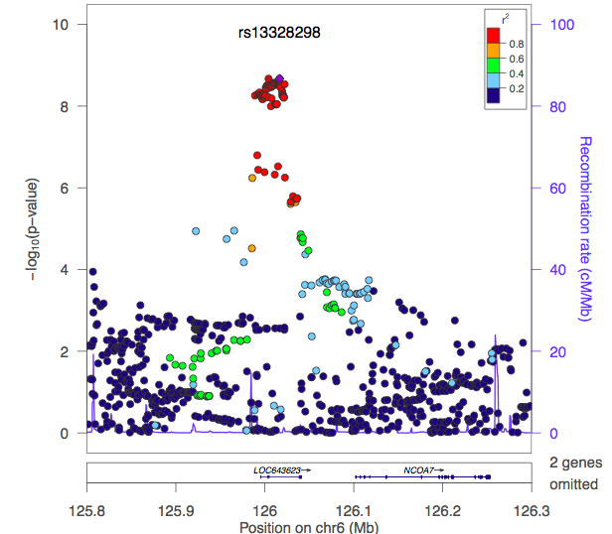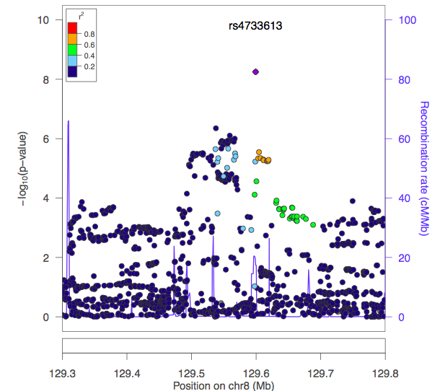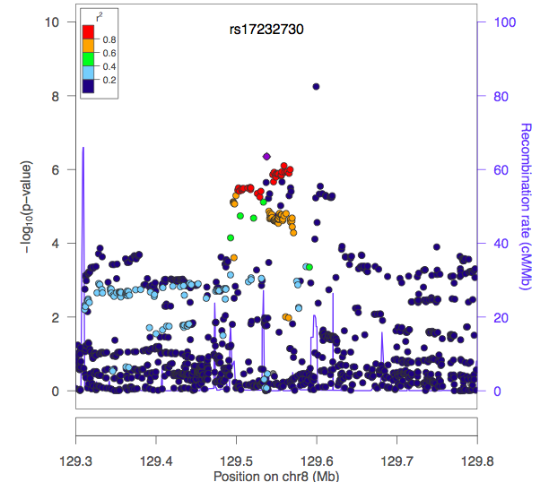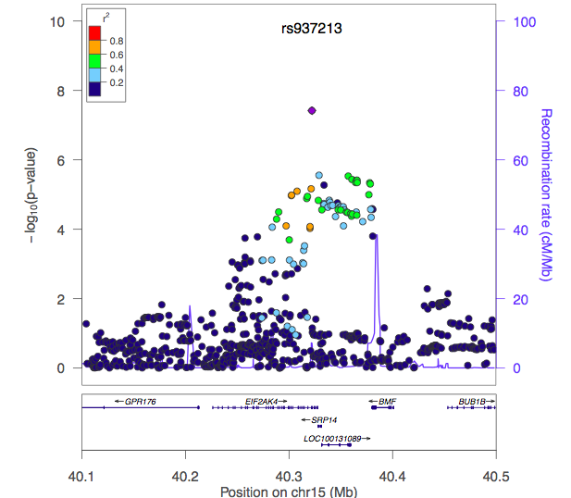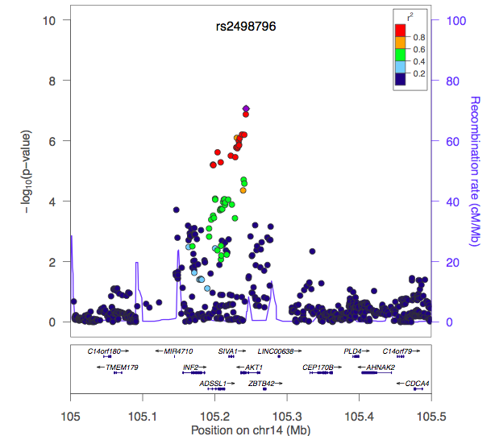

Supplementary Figure 7: Principal Components Analysis (PCA) of three GWAS and eight iCOGS studies.
Plots of the first two principal components (PCs) in each study. Endometrial cancer cases are represented by blue dots, whereas controls are in black. Samples were excluded if they clustered away from the centroid in the first four PCs and these are plots of the samples used in the analysis.

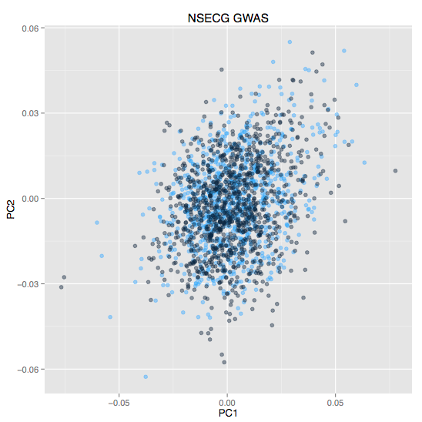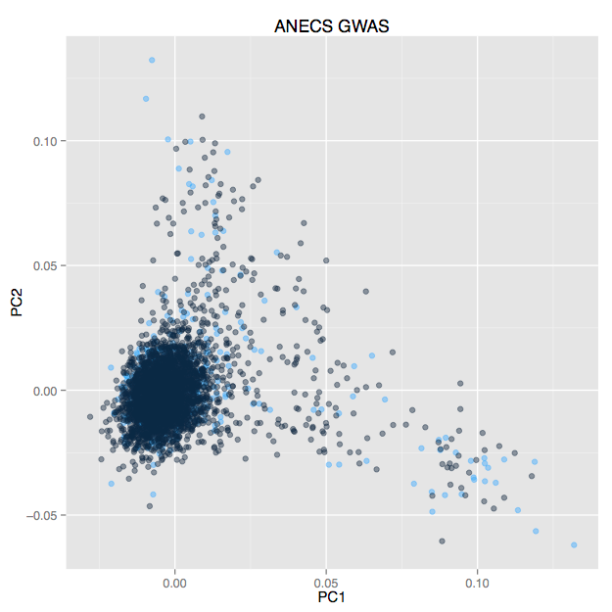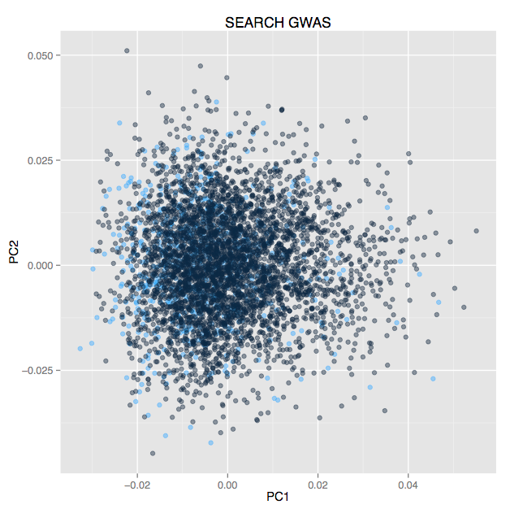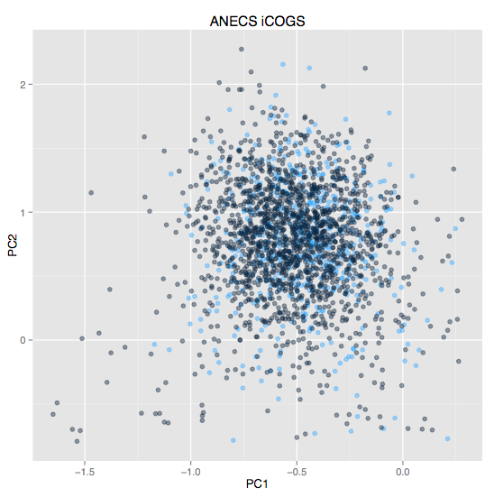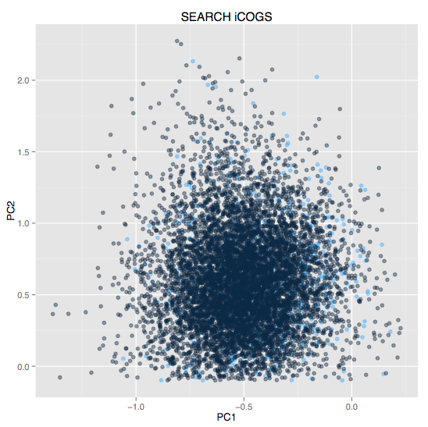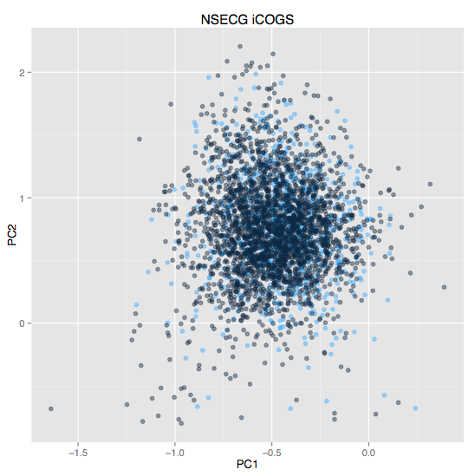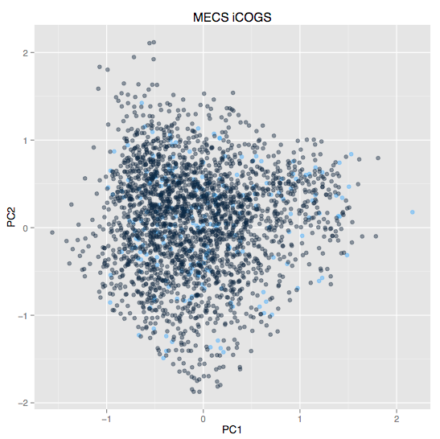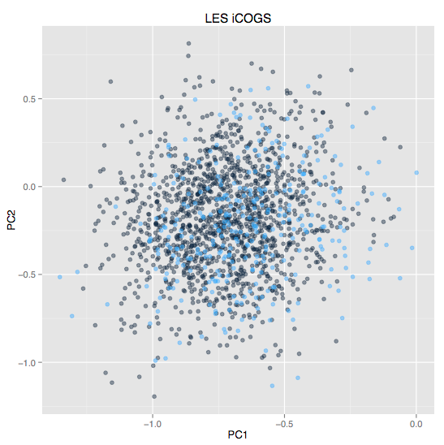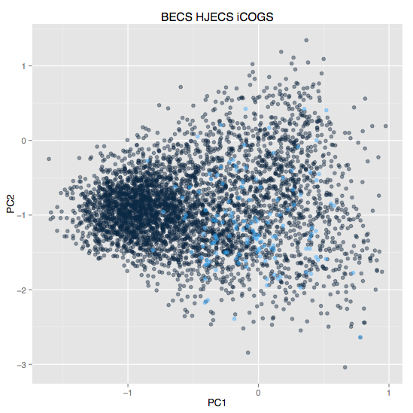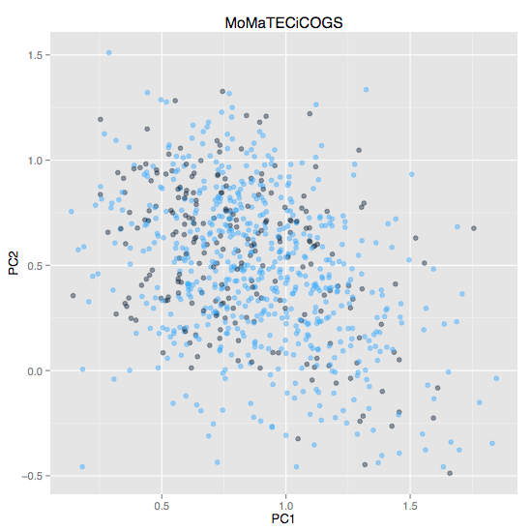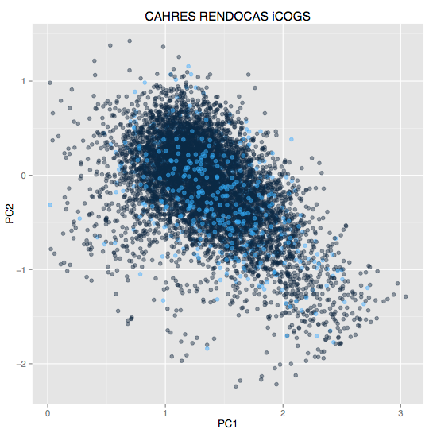
References

1. Spurdle, A. B. et al. Genome-wide association study identifies a common variant associated with risk of endometrial cancer. Nat. Genet. 43, 451–454 (2011).
2. Spurdle, A., Webb, P. & Australian National Endometrial Cancer Study. Re: Excess of early onset multiple myeloma in endometrial cancer probands and their relatives suggests common susceptibility. Gynecol. Oncol. 109, 153; author reply 154 (2008).
3. Tomlinson, I. et al. A genome-wide association scan of tag SNPs identifies a susceptibility variant for colorectal cancer at 8q24.21. Nat. Genet. 39, 984–988 (2007).
4. Tenesa, A. et al. Genome-wide association scan identifies a colorectal cancer susceptibility locus on 11q23 and replicates risk loci at 8q24 and 18q21. Nat. Genet. 40, 631–637 (2008).
5. McGregor, B. et al. Genetic and environmental contributions to size, color, shape, and other characteristics of melanocytic naevi in a sample of adolescent twins. Genet. Epidemiol. 16, 40–53 (1999).
6. Zhu, G. et al. A major quantitative-trait locus for mole density is linked to the familial melanoma gene CDKN2A: a maximum-likelihood combined linkage and association analysis in twins and their sibs. Am. J. Hum. Genet. 65, 483–492 (1999).
7. Painter, J. N. et al. Genome-wide association study identifies a locus at 7p15.2 associated with endometriosis. Nat. Genet. 43, 51–54 (2011).
8. McEvoy, M. et al. Cohort profile: The Hunter Community Study. Int. J. Epidemiol. 39, 1452–1463 (2010).
9. Wellcome Trust Case Control Consortium. Genome-wide association study of 14,000 cases of seven common diseases and 3,000 shared controls. Nature 447, 661–678 (2007).
10. Power, C. & Elliott, J. Cohort profile: 1958 British birth cohort (National Child Development Study). Int. J. Epidemiol. 35, 34–41 (2006).
11. Weiderpass, E. et al. Risk of endometrial cancer following estrogen replacement with and without progestins. J. Natl. Cancer Inst. 91, 1131–1137 (1999).
12. Wik, E. et al. Deoxyribonucleic acid ploidy in endometrial carcinoma: a reproducible and valid prognostic marker in a routine diagnostic setting. Am. J. Obstet. Gynecol. 201, 603.e1–7 (2009).
13. Salvesen, H. B., Iversen, O. E. & Akslen, L. A. Prognostic significance of angiogenesis and Ki-67, p53, and p21 expression: a population-based endometrial carcinoma study. J. Clin. Oncol. Off. J. Am. Soc. Clin. Oncol. 17, 1382–1390 (1999).
14. Salvesen, H. B. et al. Integrated genomic profiling of endometrial carcinoma associates aggressive tumors with indicators of PI3 kinase activation. Proc. Natl. Acad. Sci. U. S. A. 106, 4834–4839 (2009).
15. Ashton, K. A. et al. The influence of the Cyclin D1 870 G>A polymorphism as an endometrial cancer risk factor. BMC Cancer 8, 272 (2008).
16. Michailidou, K. et al. Large-scale genotyping identifies 41 new loci associated with breast cancer risk. Nat. Genet. 45, 353–361 (2013).
17. Pharoah, P. D. P. et al. GWAS meta-analysis and replication identifies three new susceptibility loci for ovarian cancer. Nat. Genet. 45, 362–370, 370e1–2 (2013).
18. ENCODE Project Consortium et al. Identification and analysis of functional elements in 1% of the human genome by the ENCODE pilot project. Nature 447, 799–816 (2007).
19. Korch, C. et al. DNA profiling analysis of endometrial and ovarian cell lines reveals misidentification, redundancy and contamination. Gynecol. Oncol. 127, 241–248 (2012).
20. Hnisz, D. et al. Super-enhancers in the control of cell identity and disease. Cell 155, 934–947 (2013).
21. Corradin, O. et al. Combinatorial effects of multiple enhancer variants in linkage disequilibrium dictate levels of gene expression to confer susceptibility to common traits. Genome Res. 24, 1–13 (2014).
22. Rao, S. S. P. et al. A 3D map of the human genome at kilobase resolution reveals principles of chromatin looping. Cell 159, 1665–1680 (2014).

