Needs and coordination mechanism for capacity building by the RNAS⁺

Xiao-Nong Zhou¹, Lydia Leonardo², Juerg Utzninger³, Shan Lv¹, Jing Xu¹, Arve Lee Willingham⁴, Yan Lu¹, Don McManus5, Shi-Zhu Li¹, Malu Venturina⁶, Remigio Olveda⁶, Robert Bergquist⁷

¹ National Institute of Parasitic Diseases, Chinese Center for Disease Control and Prevention; Chinese Center for Tropical Diseases Research; WHO Collaborating Centre for Tropical Diseases, China; National Center for International Research on Tropical Diseases, China; Key Laboratory of Parasite and Vector Biology, Ministry of Health, China; Shanghai 200025, China
² Institute of Biology, College of Science, University of the Philippines Diliman and University of the East Ramon Magsaysay Graduate School, Philippines
³Swiss Tropical and Public Health Institute, Basel, Switzerland
⁴One Health Center for Zoonoses and Tropical Veterinary Medicine, Ross University School of Veterinary Medicine, Basseterre, St. Kitts, West Indies
⁵QIMR Berghofer Medical Research Institute, Molecular Parasitology Laboratory, Queensland 4006, Australia
⁶Asian Tropical Foundation, Filinvest Corporate City, Research Institute for Tropical Medicine Compound, Alabang, Muntinlupa, Philippines
⁷Geospatial Health, Ingerod, Brastad, Sweden

Abstract

Introduction
With the development of Regional Network on Asian Schistosomiasis and Other Important Zoonotic Helminths (RNAS+), it was found the capacity building is one of priority activities to improve the professionals from RNAS+ member countries in terms of technical performs on modern technology as well as the traditional techniques. Particularly when endemicity of neglected tropical diseases (NTDs) is getting down with the control programme, such as schistosomiasis, liver fluke, it is urgent need to have new diagnostic tools that having much higher sensitivity compared the traditional approaches. For example, in the surveillance sites, it might underestimate the endemicity due to lower sensitivity of traditional surveillance tools. At the same time, the sensitivity of diagnostic tools will be varied due to different performance from different professional. Recently, more attention on the performance quality in the control programme which may affect the data quality, and control strategy eventually. For example, the results from the external quality assessments of national public health laboratories in detecting NTDs’ parasitic infections in 6 countries of the WHO Western Pacific Region, the overall coincidence rates for serum samples with titre of 1:40 was better than those for serum samples with titre of 1:20 or of 1:10. Detecting low levels of serum antibody in schistosomiasis patients had problematic for IHA as indicated by the low coincidence rates for serum samples with titre of 1:20 or 1:10 (<50%). There, EQA activity can identify some deficiencies occurred in the local loaboratories in endemic countries, that need to overcome and improved the laboratories’ performance in helminthiasis diagnosis. Therefore, this study demonstrate that EQA together with the training activities is really can improve the capacity in performance in laboratories.

By understanding abovementioned the needs for capacity building which directly related to the quality of control programme, the training activities arranged through RNAS+ platform have been arranged every year, usally this kind of training activities jointly held by linkage with the annual workshop of RNAS+, participated by professionals from each of RNAS+ member countries. This article will summarize the actual needs of capacity building among RNAS+ member countries and the working mechanism of capacity building last 20 years.

Needs of capacity building
RNAS+ has provided critical input with regard to several parasitic diseases of Southeast Asia, in particular with regard to schistosomiasis research. However, since various other helminthic infections are still highly epidemic in many areas of the region, and polyparasitism involving helminthiasis is common in the residents, it has been decided to extend the spectrum of the RNAS+ targeted diseases into five focal areas, i.e. schistosomiasis, cysticercosis, clonorchiasis, opisthorchiasis, and fascioliasis. Based on RNAS-organized workshop discussions on the need for the development of new techniques, implementation of ecological, epidemiology studies, the building of local technical standards and criteria, and the creation of new products and equipments.

The needs of capacity building for the RNAS+ targeted diseases are highly correlated with the research priorities of RNAS+, since most of problems occurred in performance of the national disease control programme in RNAS+ member countries are low capacity (i) in the performance of implemental researches, (ii) in the field epidemiological investigations, (iii) in the laboratory performance, and (iv) in the sociological investigation, etc.

By analysis of the research priorities for RNAS+ programme, we found it closely correlated with the needs of capacity building for RNAS+ member countries. Firstly, in the field of information management, the data handling is the basic requirement for the capacity building, which includes the research priorities on (i) documentation and development of health metrics useful in practice; (ii) promotion of GIS and remote-sensing techniques for the study of climate change and other applications. Secondly, in the field of laboratory capacity building, that covers (i) encouragement of the study of genetics and the immune responses against parasites to better understand the pathology caused and ultimately to apply for the development of a schistosomiasis vaccine, (ii) improvement and standardization of the diagnostic capabilities including development of new products, equipments and techniques; Thirdly, in the field of epidemiological and sociological research, it needs capacity on (i) Support of research on the impact of social determinants and economic issues on the epidemiology of Asian helminth zoonotic infections; and (ii) Implementation research related to control strategies. Therefore, the training activities in the abovementioned three fields were determined as training priority areas, including data handling, performance capacity in the laboratory, and epidemiological and sociological capacity in the field (Table 3-1).

Table 3-1. The relationship between research priorities and priorities of capacity building
Research priorities | Training priorities
Documentation and development of health metrics useful in practice; | Training on scientific paper writing, on surveillance data handling, on health information system for infectious diseases
Support of research on the impact of social determinants and economic issues on the epidemiology of Asian helminth zoonotic infections; | Training on social determinants on burden of diseases, on cost-effectiveness evaluation, on quick assessment methods for zoonotic infections
Promotion of GIS and remote-sensing techniques for the study of climate change and other applications; | Training on GIS and RS techniques, on impact of cliamte changes, on spatial epidemiology
Encouragement of the study of genetics and the immune responses against parasites to better understand the pathology caused and ultimately to apply for the development of a schistosomiasis vaccine; | Training on genetic population of parasite species, on immunological diagostic techiniques, on immunology and vaccine development, on molecular biology
Improvement and standardization of the diagnostic capabilities including development of new products, equipment and techniques | Training on standardization of diagnostic capacities, on new tools of diagnostics and control
Implementation research related to control strategies. | Training on implementation research, on ethical evaluation of research projects, on control strategy development and evaluation

Working mechanism of capacity building
The capacity building arranged through RNAS+ includes short training courses, individual training in member institutions, e.g. post-doctoral training, and Ph.D. or Master degree traing, as well as internship training in World Health Organization, Swiss Tropical and Public Health Institute in Basel of Switzerland, QIMR Berghofer Medical Research Institute in Queensland of Australia, Research Institute of Tropical Medicine in Philippine, University of Philippines, National Institute of Parasitic Diseases at China CDC in Shanghai of China, Veterinary University of Khon Kaen in Thailand, etc.
Firstly, a total of ### short training courses linking with the annual workshops of RNAS+ is the major way to improve the capacity of professional for each member countries. The contents of each short training course was based on the needs and priorities of capacity building of the member countries and decided by the RNAS+ board. Therefore, short training courses on information management and the data handling, diagnosis with laboratory techinologies, and sociological researches were arranged, such as training courses on development of health metrics, on GIS and remote-sensing techniques, on molecular biology, on immunological diagnostic tools, on schistosomiasis vaccine development, standardization of B-ultra sound examination, on diagnostic techniques, on epidemiological surveillance, on sociological research, on social determinants and economic evaluation, on improving control strategies, and on ethical issue for research, etc.
Secondly, more than 20 young scientists had been trained in institutions from member countries through RNAS+ platform. Those training varied from one months to one year. For example, three young scientists from Medical Research Department, MoH of Myanmar had trained in the National Institute of Parasitic Diseases at China CDC in the field of drug development and entomology; Two young scientists from the National Institute of Parasitic Diseases at China CDC were trained on molecular biology in QIMR Berghofer Medical Research Institute in Queensland of Australia; More than 10 young scientists from China, Cambodia and Lao PDR were trained as Ph.D. students on epidemiology, data modeling, drug efficacy evaluation, and control strategies of NTDs, in Swiss Tropical and Public Health Institute in Basel of Switzerland; More than 5 students as Ph.D. or Master students from China, Lao PDR, Indonesia, were individually trained in University of Philippines.
Thirdly, more than five 10-days training courses on scientific paper writing were held in Research Institute of Tropical Medicine in Philippine and the National Institute of Parasitic Diseases at China CDC, in addition to the 1 or 2-days short training courses were arranged liking to the RNAS+ annual workshop. The major success of the 10-days training course targeted to help young scientists to publish their scientific papers within one year post-training, with an assistance of the course mentors. More than 100 young scientists from RNAS+ member countries were trained which had improved their capacity on writing scientific papers significantly.
Fourthly, more than 10 young scientists from RNAS+ member countries were trained as internship fellow in WHO Office at different levels, including country office, regional office, and headquarter office. Since RNAS+ member countries cover both WHO Western Pacific Region and WHO South-East Asia Region, so that both Western Pacific Regional Office and South-East Asia Regional Office have opened the internship opportunities for the young scientist from RNAS+ member countries. By internship training, those trainers had not only improved their view of global health but also lifted their networking capacity with stronger coordinating skills.
Fifthly, an external quality assessment (EQA) on reference or public health laboratories on NTDs at national level in selected countries in the WHO Western Pacific Region was held from 2012 to 2015, organized by the National Institute of Parasitic Diseases (NIPD) of Chinese Center for Disease Control and Prevention (CDC) based in Shanghai, China. Two representatives of each participating laboratory were invited to NIPD to detect NTDs’ parasitic infections using the same prepared samples for serological tests (IHA and ELISA) and helminth eggs’ morphological tests (Direct smear and Kato-Katz). Training activities were also given to those participates right after the EQA aiming to improve the detection capacity on NTDs in the region.
Abovementioned four channels of training have significantly improve the young scientists from member countries on capacity of both research and control programme, which not only provided the opportunities for the young scientists from Asia but also has made remarkable impacts of RNAS+ to the world. In addition, there are also other means to have scientific exchanges or study tours on schistosomiasis control programme, such as study tours from Indonesia and Philippines to China which help not only the scientist to exchange the techniques but also the government officers to understand the importance of multi-sectoral cooperation in the control of schistosomiasis.
Case study of capacity building
Here, we selected some of samples on capacity build to demonstrate the proper training really improve the carrier development for the young scientists, including (i) a training course in China with focus on the field training on standardization of the diagnosis in schistosomiasis elimination stage, (ii) Dr. Somphou Sayasone who completed the Ph.D. study at Swiss Tropical and Public Health Institute and back to Lao PDR to continue his study on Schistosoma mekongi, and now serving as current President of RNAS+, (iii) the achievements of the 10-days training courses on scientific paper writing held in Research Institute of Tropical Medicine in Philippine, (iv) Dr. Men-Bao Qian who took the internship in WHO HQ on zoonotic diseases control which help him to finish his Ph.D. study in China, (v) Achievements of EQAs on NTDs.
Case study 1: Field training on standardization of the diagnosis in schistosomiasis elimination stage (Xu Jing).

Case study 2: Dr. Somphou Sayasone become the President of RNAS+ after several years of completing his Ph.D. study at Swiss Tropical and Public Health Institute (Somphou Sayasone).

Case study 3: Achievements of the 10-days training courses on scientific paper writing held in Research Institute of Tropical Medicine in Philippine (Malu).

Case study 4: Improvement of research capacity on zoonotic diseases for Dr. Men-Bao Qian who took the internship training in WHO HQ (Qian MB)

Case study 5: Achievements of EQAs on NTDs from 2012 to 2015 (Lu Yan).

Capacity building opportunities
The opportunities of training through the RNAS+ platform is mainly contributed by several host institutions that proactively involved in the RNAS+ activities, including Swiss Tropical and Public Health Institute in Basel of Switzerland, QIMR Berghofer Medical Research Institute in Queensland of Australia, Research Institute of Tropical Medicine in Philippine, University of Philippines, National Institute of Parasitic Diseases at China CDC in Shanghai of China, Veterinary University of Khon Kaen in Thailand, etc. Therefore, the capacity building opportunities from each institutions is reviewed as follows.
Swiss Tropical and Public Health Institute in Basel of Switzerland (Juerg Utzinger):

QIMR Berghofer Medical Research Institute in Queensland of Australia (Don McManus)

Research Institute of Tropical Medicine in Philippine (Malu):

University of Philippines (Lydia):

National Institute of Parasitic Diseases at China CDC (Ding Wei):

Veterinary University of Khon Kaen in Thailand (Bonchop Sripa):

Conclusion
The overall aim of RNAS+ is to strengthen collaboration and control authorities in the endemic countries and the network has provided critical research input with regard to several parasitic diseases of Southeast Asia, with regard to schistosomiasis and other helminthic infections, including polyparasitism. New initiatives addressing neglected tropical diseases are urgently needed and there is an increasing awareness of the role of the climate and the environment leading to changing epidemiological patterns. Rapid growth of key technologies (health metrics, GIS, etc.) and the development of evidence-based policies are seen as important. Based on RNAS-organized workshop discussions on the need for speedy progress and building of local technical standards, it was agreed that available mechanisms for information sharing should include network frameworks, website, databases, publications and meetings.
To make progress towards these goals, it has been decided focus on platform design and technical standardization aiming at fostering research capacity and the development of networking capacities and easy access to information databases. The sketch shown below has depicts an administrative body acting as centre for network members to interact. It is proposed that it be housed in the Research Institute for Tropical medicine (RITM), Department of Health, Manila, the Philippines.
This administrative body would be largely virtual connecting the RNAS+ members via the Internet, providing with database and administrative back-up. There would be no salaried parts, possibly except director and secretariat that could be on part-time schedules. This strategy reflects the tactic to boost research on the target diseases with a strong emphasis on ways and means to alleviate the scepter of the disease and poverty. The current thinking is that the overall goal would benefit from the creation of interconnected disease-specific groups capable of operating as “nodes” on the RNAS+ website (http://www.rnas.org.cn).

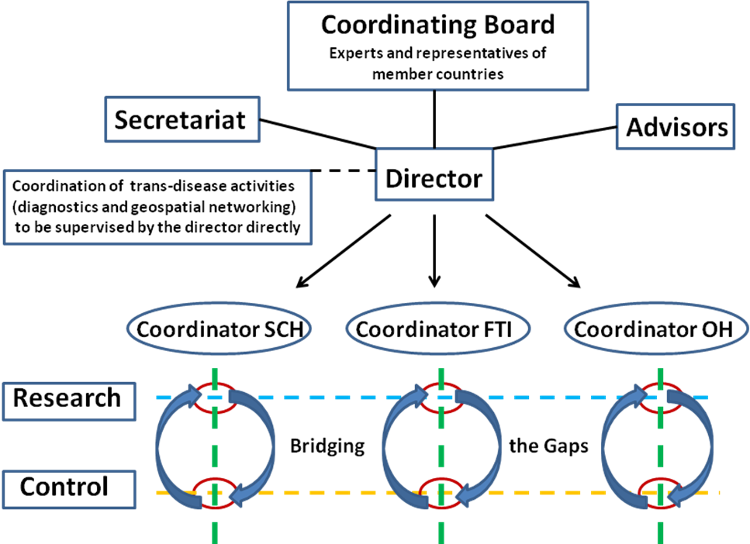
FIGURE 1: Schematic functioning of RNAS+

The raison d’être of the organization is to review research evidence, evaluate its relevance, assess challenges in disease control, highlight new scientific advances, and provide independent guidance on priority areas and research gaps. This creates a flexible, interactive grid of excellence, avoiding the conventional "review-board" approach and instead encouraging a focus on gap assessments and opportunities. Thus, in contrast to the one-dimensional summing up of scientific developments in the different sectors of activity, a better vantage point is gained encouraging true research innovation. On the other hand, the challenge is to make the approach rigid enough to function as a one-stop repository of up-to-date information, yet sufficiently flexible to permit exchange of novel ideas. By building a knowledge base with the diseases set into a socially and epidemiological context, a wider scope in fighting maladjustments in the overall public health panorama is achieved. This approach is based on key activities such as:
- Retrieval of data of particular interest and identifying areas where RNAS can fill a need;
- Identification of knowledge gaps and promotion of innovative synthesis of findings relevant to infectious diseases control in settings characterized by poverty; and
- Get researchers acquainted with the advantages of working via the RNAS+ website as a, knowledge management platform for data distribution, and encourage them to actively participate in a joint effort to continuously update information on the diseases of poverty.
In spite of specifically developed search engines for the Internet, the dissemination of scientific results continues to be shackled with slow and inefficient mechanisms. Without access of the best available evidence, practice constantly risks falling behind to the detriment of controlling endemic diseases. Amazingly, even today it can take up to 17 years for new knowledge generated by randomized trials to be implemented in medical practice (IOM). By building a knowledge base of geographical distributions of endemic areas and the relative risk for infection based on marrying epidemiological data with a map-presenting vehicle, e.g. Google Maps, an interactive map service based on satellite/aerial imagery, RNAS+ aims to become a leader in health metrics in the region.
Evidence-based medicine (EBM) is a tool for rapid knowledge dissemination. Rather than focusing on saving the costs of health care by simple cost-cutting, public health officers practicing EBM can and will identify and apply the most efficacious interventions to maximize the impact of their efforts, an approach that may raise rather than lower the overall cost. EBM was originally developed to improve individual patient care but could easily be used for advising control efforts in endemic countries. However, any external guidelines must be integrated with epidemiological expertise in deciding whether and how it matches the endemic predicament and preferences, and thus how it should be implemented. EBM is not restricted to randomized trials and meta-analyses. It involves finding the best external evidence with which to answer clinical questions. To track down the accuracy of a diagnostic test, proper cross-sectional studies need to be identified and, for prognosis, proper follow-up studies of infected subjects assembled at uniform points need to be retrieved. With regard to therapy, non-experimental approaches should be avoided since these routinely lead to false-positive conclusions about efficacy. Because the randomized trial, and especially the systematic review of several such trials, is so much more likely to provide the information needed, it has become the “gold standard” for judging whether a treatment does more good than harm.
A number of institutions provides information for the assessment of health needs in the world. These are international donor agencies, non-profit organizations, or business-oriented companies. They differ in approach and scope and to make a difference, TDR needs to profile itself not to emulate any of them completely. Some examples include:
The Institute of Medicine (IOM) of the National Academies (USA) provides science-based advice on matters of biomedical science, medicine, and health. The IOM was chartered as a nonprofit organization in 1970 as a component of the National Academy of Sciences. The Institute works outside the framework of government to ensure scientifically informed analysis and independent guidance. Its main mission is to serve as adviser to USA to improve health there but its resources are also open to outside users. The IOM provides unbiased, evidence-based, and authoritative information and advice concerning health and science policy to policy-makers, professionals, leaders in every sector of society and the public at large.
The Cochrane Collaboration, founded in 1993, is an international, not-for-profit, independent organization that produces and disseminates systematic reviews of healthcare interventions. In particular, it promotes the search for evidence in the form of clinical trials. Cochrane provides up-to-date, accurate information about the effects of healthcare worldwide. Its major product is the Cochrane Database of Systematic Reviews which is published quarterly as part of “The Cochrane Library”. The reviewers are healthcare professionals who volunteer to work in one of the many “Cochrane Review Groups” with editorial teams overseeing the preparation and maintenance of the reviews.
The Oxford Centre for Evidence-Based Medicine was established in 1995 with the aim to develop, teach and promote evidence-based health care. Evidence-based medicine is the conscientious use of current best evidence in making decisions about the care of individual patients. The practice of evidence-based medicine means integrating individual clinical expertise with the best available external clinical evidence from systematic research. It is based on the best available, clinical evidence and relevant research gleaned from the basic sciences of medicine, but especially from patient-centred clinical research into the accuracy and precision of diagnostic tests, the power of prognostic markers, and the efficacy and safety of therapeutic, rehabilitative, and preventive regimens.

